Chapter 12, Solution 15.

Convert the delta load, 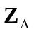, to its equivalent wye load.
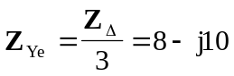

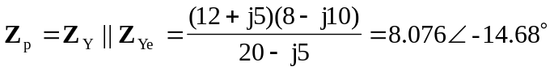
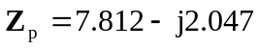

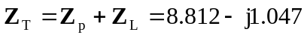
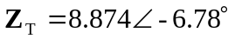

We now use the per-phase equivalent circuit.
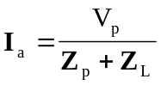, where 